**Water Weather Station**

**CSCI 492: Sprint 1**

**By: Bryan Pham and Caleb Ponce**

# Stories:

Story: Students are curious about the body of water that is near their campus, so they wanted to build a buoy so they could put in that body of water. The buoy will be able to collect the temperature of the surface, right under the surface, 2 meters below the surface, salinity, turbidity, and light.

We are going to put together the buoy with the necessary sensors and ESP32 board so it will be able to send out the signal via bluetooth to an Android device, and when the Android device has connected the data, it could upload it to the website and its database.

Story: Kids at the summer camp want to test how clear the water is for their experiment. Using a turbidity sensor will help measure the clarity of the water by sending inferior red light to each other sensor (Look the figure 1 below).

Story: A student has finished assembling and collecting their data from their water weather machine. The next thing to do is upload the data to the website and view it. Going to their computer they register their username and password to allow them to access the database.

# Sprint 1:

For this sprint 1, I will be implementing a function to add your own username and password as well as adding mock data to make the design of what it will be when real data comes in. If there is time, I would also like to implement the connection between the app and the website. With another member of the project that knows more about android apps than me.

For this sprint 1, I will be implementing a turbidity sensor to the buoy. The turbidity should be able to measure the clarity of the water by sending inferior red light to each other.

Example of Turbidity:

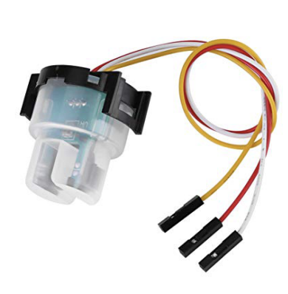

Figure 1: Turbidity Sensor.

How to connect the Turbidity to the ESP32 on the breadboard:

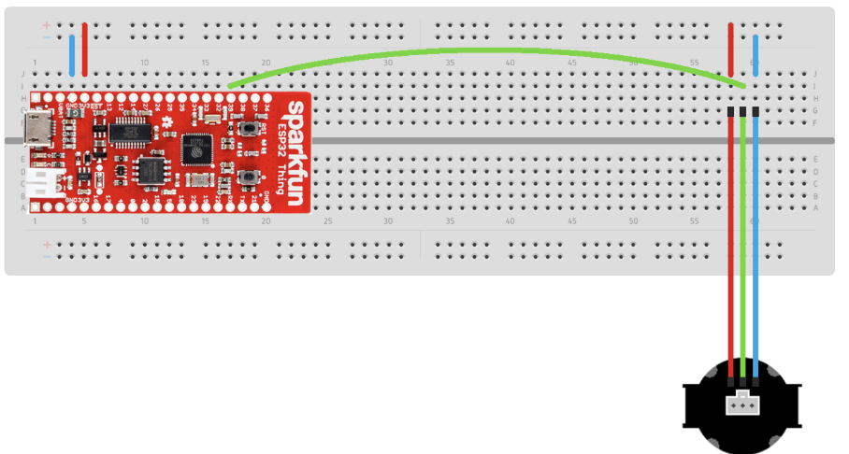

Figure 2: Connecting the Turbidity Sensor.

The turbidity sensor is connected to the board by a set of M-to-F jumper wires. Orienting the sensor as shown, the power pin is on the left, the data pin is in the middle, and the ground pin is on the right. Insert the jumper wires into columns 58,59, and 60, and connect each to the appropriate sensor pin. Then connect column 59 to pin 39 of the ESP32 in column 17.